🧪 LAB: 100% Disk Utilization (Create + Resolve)

🎯 Step 1: Create the Problem (Fill Disk)
⚠️ Do this in a test folder (not root)
mkdir disk_test && cd disk_test

Create large files to fill disk:
dd if=/dev/zero of=bigfile1 bs=100M count=50
dd if=/dev/zero of=bigfile2 bs=100M count=50
👉 This creates ~10GB (adjust if needed)

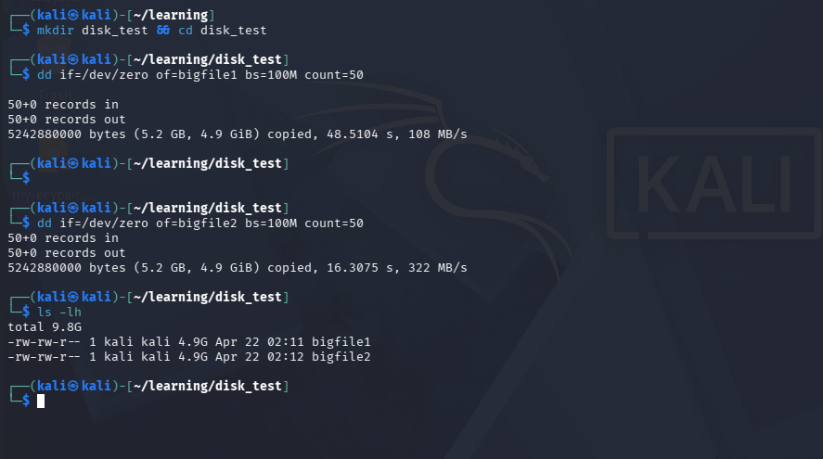

🔍 Step 2: Check Disk Usage
df -h
👉 Look for:
- Disk at 35%
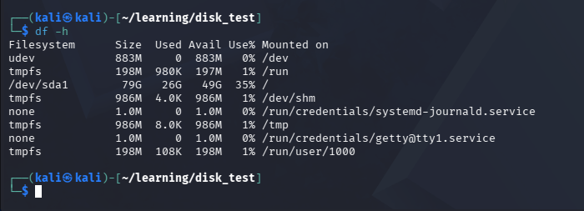

🔎 Step 3: Find What is Using Space
Option 1: Check folder sizes
du -sh *


Option 2: Deep analysis
du -ah . | sort -rh | head -10
👉 Shows top space consumers


⚠️ Step 4: Check Logs (Common real issue)
du -sh /var/log/*
👉 Often logs fill disk
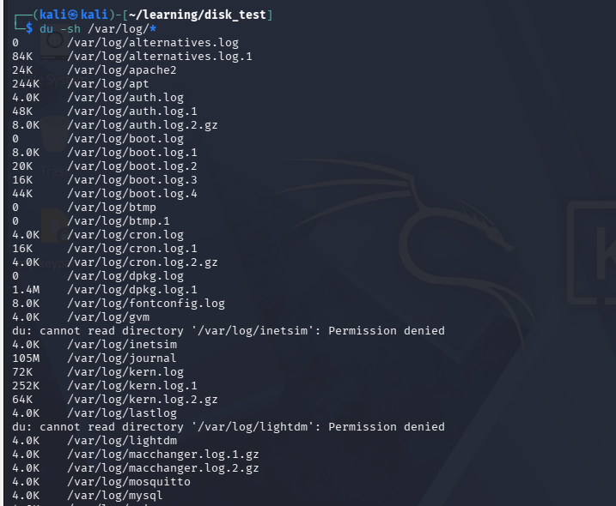

🛠️ Step 5: Fix the Issue
Option 1: Delete large files
rm -f bigfile1 bigfile2


Option 2: Clean logs
truncate -s 0 /var/log/syslog
or
rm -rf /var/log/*.log

🔁 Step 6: Verify Fix
df -h
👉 Disk usage should drop
